35th INTERNATIONAL CONFERENCE ON PSYCHOLOGY AND THE ARTS
Center for Advanced Academic Studies, Dubrovnik, Croatia

June 26 – July 2, 2018
_________________________________________________________________________________

PRACTICAL INFORMATION
– Prepared by Vlasta Brunsko, Head, Centre for Advanced Academic Studies (CAAS), Dubrovnik

We hope you will find the following information helpful in planning your visit to Dubrovnik. The Centre for Advanced Academic Studies of the University of Zagreb in Dubrovnik (CAAS) as the host institution for ESEIA INTERNATIONAL SUMMER SCHOOL 2017 is welcoming you end of June.

Arrival to Dubrovnik: After arriving to Dubrovnik Airport you can take a taxi to your respective accommodation (the price is approx. 35 €). The journey takes about 25 minutes. You can also take a bus that leaves the airport after every landing of regular flights and takes you to the City. These buses will be marked on the window shield with the sign Airport – Dubrovnik and the bus fare is 40 kuna (approx. 5 €). If you are staying at CAAS tell the airport bus driver that you are getting off at Pile. When you get off at the Pile stop keep walking for approximately 300 meters, in the same direction as the bus was travelling, until you come to the Cafeteria Sesame. In front of Cafeteria Sesame you will see about 20 steps. Take these steps to reach the CAAS building.

If you are staying somewhere else you can take the bus from the airport to the Pile stop and from there a local bus. The bus tickets can be purchased at any newsstand on Pile. On Pile there is also a taxi stand. In general, taxi can be reached at any place and any time.

Taxi Services in Dubrovnik:
Taxi | Tel. (+385) (0)20332222
Taxi | Tel. (+385) 08000970

The venue: CAAS is located in the very heart of Dubrovnik, less then five-minute walk from the Old
City. Everything you need is within walking distance: shops, banks, restaurants, beaches, bus station, taxi stand, etc. The address is: Don Frana Bulica 4.

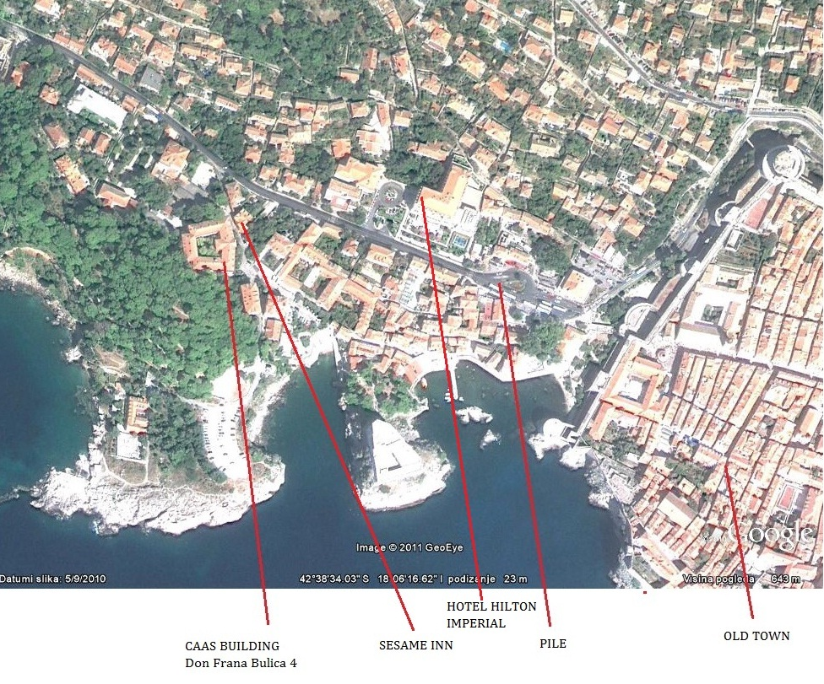

CAAS CONTACT

Centre for Advanced Academic Studies (CAAS) | Vlasta Brunsko  Head of Office  Tel. +385 20 326 380, Fax. +385 20 326 390  E-mail: vlasta.brunsko@caas.unizg.hr

Internet: Free WI-FI is available everywhere in CAAS building by using the password hanging on the walls. CAAS has also a Computer room available to all participants.

Travel: For all flights to and from Dubrovnik please visit
http://www.airport-dubrovnik.hr/index.php/hr/ .

Travel documentation: Passport or some other internationally recognized identification document. Information about visa regime between the Republic of Croatia and other countries available at: http://www.mvep.hr/en/ .

Weather: There are two climate zones in Croatia. A temperate continental climate prevails in the interior, whereas a pleasant Mediterranean climate prevails along the Adriatic coast with sunny days throughout most of the year, dry and hot summers and mild and humid winters. Average June temperature in Dubrovnik varies between 25°C and 30°C. Most indoor places, like CAAS, are air-conditioned. To check the current and five-day forecast for Dubrovnik please visit: http://weather.yahoo.com/forecast/HRXX0001.html.

Time Zone: GMT plus one hour in winter and GMT plus two in summer.

Water: Tap water is drinkable throughout Croatia.

Post Offices: Post offices are generally opened Mo-Fr from 8:00 to 19:00 and on Saturdays until 13:00. Postage stamps can be purchased in post offices and at newsstands.

There are several mobile phone (GSM network) providers in Croatia. If you don’t have roaming service, we advise you to make respective arrangements with your local network provider before departure. Upon arrival to Croatia, one of the Croatian network providers will automatically appear on your display. For telephone charges make sure to check details with your local network provider. The international country code for Croatia is +385 and the area code for Dubrovnik is 020 (when dialling from within Croatia; do not dial the first zero when calling from abroad).

Banking hours: Banks are generally opened Mo-Fr from 8:00 to 20:00. On Saturdays banks are open until 12:00. Most common credit cards, such as American Express, Diners, Eurocard/Mastercard and Visa are widely accepted at hotels, restaurants, shops, supermarkets, etc.

Cash Dispensing/Automated Teller Machines (ATMs; Bankomat in Croatian) are located all around the town.

Working Hours: Shops and department stores are open Mo-Sa from 8:00 to 20:00. A smaller number of stores may close between 12:00 and 16:00. Many stores are also open on Sundays, especially during the summer. Public services and companies generally work Mo-Fr from 8:00 to 16:00.

Currency: The currency unit in the Republic of Croatia is the kuna (HRK or Kn), which is divided into 100 lipa. Banknotes exist in denominations of 5, 10, 20, 50, 100, 200, 500 and 1,000 kuna. Foreign currencies can be exchanged at banks, exchange offices, post offices, travel agencies, hotels, camps, marinas, while checks/cheques can be cashed in at banks. The current exchange rates are approximately: 1 € = 7,5 Kn, 1 $ = 6,3 Kn. For most current rates you may check the website of the Croatian National Bank http://www.hnb.hr/en/home .

Tipping: A tip is not obligatory, but small change is always welcome. Taxi drivers, porters, hairdressers, etc., will always appreciate a small tip.

Safety and Medical Care: Croatia is considered a safe country with a very low crime rate. You may walk freely throughout the city at all times. You are encouraged, however, to take normal precautions to ensure your safety.

Medical assistance is available in hospitals providing 24-hour emergency service. Foreign tourists do not pay for medical services if a Health Care Agreement was signed between Croatia and their respective country of origin. In case of an emergency, you should call 112.

Pharmacies/Drug Stores are open from 8:00 until 20:00. Names, addresses and telephone numbers of pharmacies that remain open until late at night on public holidays and on Sundays, are listed in daily papers or call 18981.

Electrical System: The electrical system in Croatia is based on 220V, frequency 50Hz and requires two-pronged wall plugs. Visitors from other countries may need to bring a voltage adapter and/or a plug adapter for their electronic devices. Please check your current adapters to see if they will accept up to 220V.
Departure from Dubrovnik/CAAS: The route for the proposed departure from CAAS to Dubrovnik Airport is a bit different the one for arrival. The airport bus that leaves from the City to the airport has its starting point at the GRUZ BUS TERMINAL which is not as close to CAAS. These buses are leaving every 90 minutes before domestic and 120 minutes before international flight, but it is recommended to check with Dubrovnik bus terminal (+ 060 305 070 ) a day before about the exact time of bus departure. To get from PILE to the GRUZ BUS TERMINAL you should take the local bus No. 1 or 8. Ticket for local bus can be obtained on any newspaper stand for 12 KN (cca. 1,4€). Please note that these transfers are valid for regular flights only, not for charter flights. Ticket for airport bus can be obtained on the bus for the price of 40 KN (cca. 5€). The other option is to call radio-taxi on 08000970 or (020)332222 or walk to PILE where you can find taxi any time. To the airport it costs 260-280 KN (cca. 35€). From 8 a.m. till 5 p.m. the traffic is very tense because of the buses that bring passengers from cruisers into the Old City. Therefore we strongly suggest you leave on time.
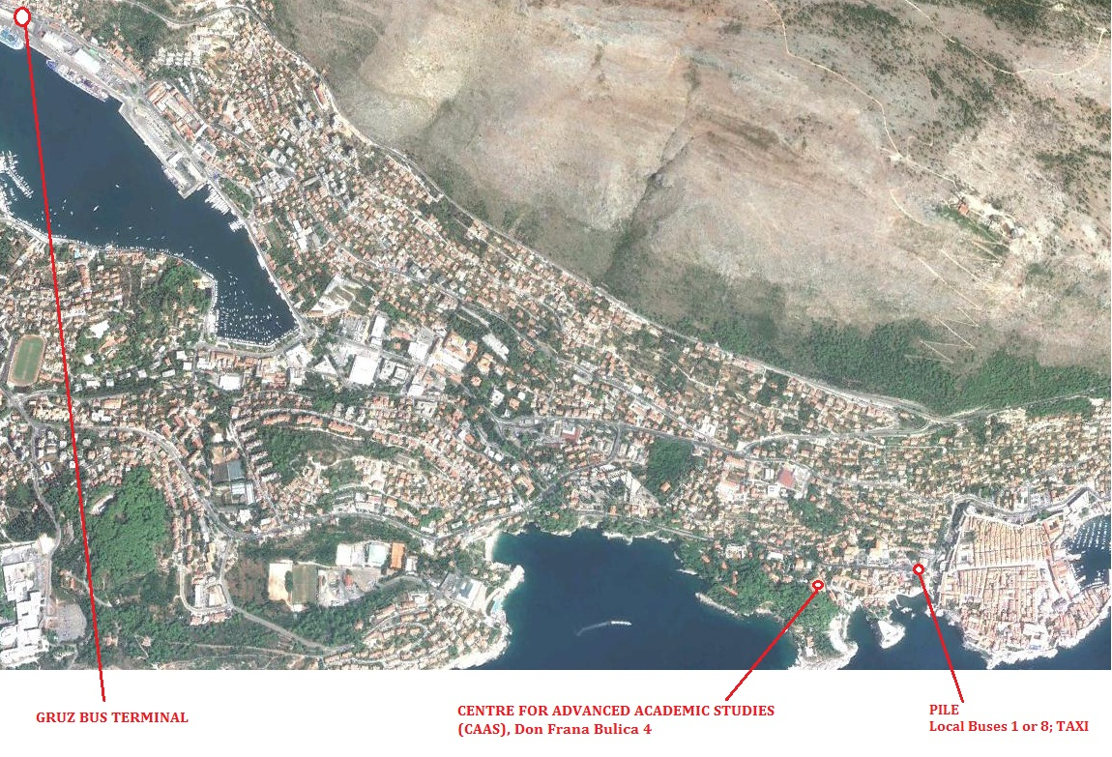

USEFUL WEB SITES

Croatia
Croatian Homepage | http://www.hr
Croatian National Tourist Board | http://www.croatia.hr
Dalmatia Travel Guide | http://dalmacija.net/site/home/

Dubrovnik
Dubrovnik Tourist Board | http://www.tzdubrovnik.hr
Dubrovnik Online | http://www.dubrovnik-online.com
The Best in Dubrovnik | http://www.bestindubrovnik.com
Dubrovnik Museums | http://www.mdc.hr/dubrovnik

Croatia Airlines
Croatia Airlines | http://www.croatiaairlines.hr  Zagreb Office: (+385) 1 6164 582  Dubrovnik Airport Office: (+385) 20 772 232

City Bus transportation
Libertas | http://www.libertasdubrovnik.hr  Central Bus Station: (+385) 20 060 30 50 70

Travel Agencies
Dubrovnik Travel | http://dt-croatia.com
Elite | http://www.elite.hr
Gulliver Travel | http://www.gulliver.hr/en

BACKGROUND INFORMATION AND CULTURAL/TOURISTIC OFFER

Croatia extends from the furthest eastern edges of the Alps in the northwest to the Pannonian lowlands and the banks of the Danube in the east; its central region is covered by the Dinara mountain range, and its southern parts extend to the coast of the Adriatic Sea. The mainland covers 56,542 km², and the surface of the territorial sea is 31,067 km². The coastline of Croatia is 5,835 km long in total of which 4,058 km belongs to islands, solitary rocks and reefs. Hence, Croatia is often also referred to as “the country of thousand islands.” For detailed travel information (maps, etc.) and other general information about the Republic of Croatia (e.g. Croatia’s traditional cuisine and wine), including a number of photos, please visit the following website: http://www.croatia.hr.
The city of Dubrovnik is situated in Southern Dalmatia, the most beautiful part of the Adriatic coast. Rich vegetation, beautiful lakes, rare islands, white pebble beaches and the crystal clean sea, all make this region an unforgettable experience for every visitor. Tourism as a tradition dates back to over one hundred years ago, with the Hotel Imperial being one of the oldest hotels in Dubrovnik. Dubrovnik is now the administrative seat of Dubrovnik-Neretva County and while travelling through this region visitors must take time to explore the harmony between man and nature that is part of everyday life here. Dubrovnik region consists of numerous small "jewels" that are worth visiting, small authentic villages, untouched islands and, of course, the Old Town of Dubrovnik, the crown jewel of them all.

Short history of Dubrovnik

Dubrovnik was founded in the first half of the 7th century by a group of refugees from Epidaurum (today's Cavtat). They established their settlement at the island and named it Laus. Opposite of that location, at the foot of Srđ Mountain, Slavs developed their own settlement under the name of Dubrovnik (named by “Dub” - type of wood). The settlements were separated by a channel which was filled in the 12th century, the present Placa or Stradun, and since than the two settlements have been united. At that time the city walls started to be built as a protection from different enemies (Arabs, Venetians, Macedonians, Serbs, etc.) all of whom wanted to conquer Dubrovnik.

From its establishment the town was under the protection of the Byzantine Empire that helped Dubrovnik in the wars against Saracens (886-887 AD), Bulgaro-Macedonians (988), and Serbs (1184). After the Crusades, Dubrovnik came under the sovereignty of Venice (1205-1358), and by the Peace Treaty of Zadar in 1358 it became part of the Hungarian-Croatian Kingdom. Having been granted complete self-government, bound to pay only a tribute to the king and providing assistance with its fleet, Dubrovnik started its life as a free state that reached its peak during the 15th and 16th centuries. In 1526 Dubrovnik acknowledged the supremacy of the Turkish Sultan (annual tribute was paid to the Sultan). A crisis of Mediterranean shipping, and especially a catastrophic earthquake on the 6th of April 1667 that killed over 5 000 citizens, including the Rector, leveling most of the public buildings, ruined the well-being of the Republic.

With great effort the Republic recovered to a certain degree, but still remained a shadow of the former Republic. In 1806 Dubrovnik surrendered to French forces, as that was the only way to cut a month's long siege by the Russian-Montenegrin fleets (during which 3,000 cannon balls fell on the city). The French lifted the Russian-Montenegrin fleets and saved Dubrovnik for the time being. The French army, led by Napoleon, entered Dubrovnik in 1806. In 1808 Marshal Marmont abolished the Dubrovnik Republic.

In 1809 Dubrovnik became part of the Illyrian Provinces. In 1815, by the resolution of the Vienna Congress, Dubrovnik was annexed by Austria (later Austria-Hungary), and remained annexed until 1918 when it became part of the Kingdom of Serbs, Croats, and Slovenes. At the very beginning of World War II, Dubrovnik was first part of the Independent State of Croatia. From April 1941 until September 1943 Dubrovnik was occupied by Italian army followed by German forces. In October 1944 Partisans liberated Dubrovnik from the Germans. In 1945 Dubrovnik became part of the Federative People's Republic of Yugoslavia, which changed its name to the Socialist Federal Republic of Yugoslavia (SFRY) in 1963, consisting of six republics. Dubrovnik was part of the Socialistic Republic of Croatia.

In 1990 SFRY dissoluted resulting in the independence of its previous constituent republics, including the Republic of Croatia. On October 1, 1991 Dubrovnik was brutally attacked by the former Yugoslav National Army, aided by paramilitary forces. The military assault lasted for seven months, and in May 1992 the Croatian Army liberated Dubrovnik and its surroundings, but the danger of renewed and sudden attacks lasted for another three years. Today, Dubrovnik is a free and safe town, globally known, and the most popular tourist destination in Croatia.

Places of interest

The particularity and uniqueness of Dubrovnik is its permanent live connection to its rich past and its cultural heritage, while it keeps vibrantly in pace with contemporary life, echoing its spiritual identity and its presence in the European cultural environment. Since 1979 the Old City is on the UNESCO World Heritage List.

The most recognizable feature which defines the history of Dubrovnik and gives it its character are its intact City walls which run uninterrupted for 1940 meters encircling the city. This complex structure, one of the most beautiful and strongest fort systems in Europe, is the main attraction for the city's visitors. Five fortresses, St. Lawrence and Revelin together with another three incorporated in the city walls, Minčeta Tower, Fort Bokar and St. John's Fortress provide its visitors with unforgettable views of the city. Weddings are held in the small St. Lawrence's chapel or on Minceta Tower. Performances and concerts are organized on Fort Revelin, St. Lawrence and St. John's fortresses during the Summer Festival.

The State Archives in the Sponza Palace, which contains documents from the 12th century on, attracts those who would like to know more about the political, economical and cultural relations between the Dubrovnik Republic and other European countries in the past.

The Franciscan monastery with the museum that contains the Old Pharmacy's inventory dates back to 1317 and is a curiosity to its visitors. The Dominican monastery, which contains a collection of the Dubrovnik School of Art from the 15th and 16th centuries, the Treasure of the Cathedral with the reliquary and the Rector's Palace are major attractions as well.

There are five museums in Dubrovnik today. The Archaeological and the Modern History Museum still do not have permanent premises in which to display their collections. The Ethnographic Museum is situated in the former granary at Rupe (Hole) location. The Cultural-Historical Museum is situated in the Rector's Palace. The collection of the Maritime Museum found its place in the St. John's Fortress.

Finally, if you wish to read even more detailed pieces of information on Dubrovnik, let us suggest you visit Dubrovnik Tourist Board website: http://www.tzdubrovnik.hr/eng .

